**noK&O Pest Control Site Documentation**

**URL** :- <http://www.kandopestcontrol.co.uk/>

**Admin URL** :- <http://www.kandopestcontrol.co.uk/wp-admin/>

**UserName** :- Vicki

**PassWord** :- aT70XOfLoQ)0)q$23lUxivoD

1. **Header Setting :-**

**(i) How to manage Header Logo :-**

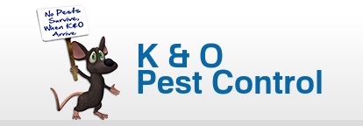

**Go to admin panel Dashboard -> Theme Settings -> Header Settings, we can change or edit according to screenshot :-**

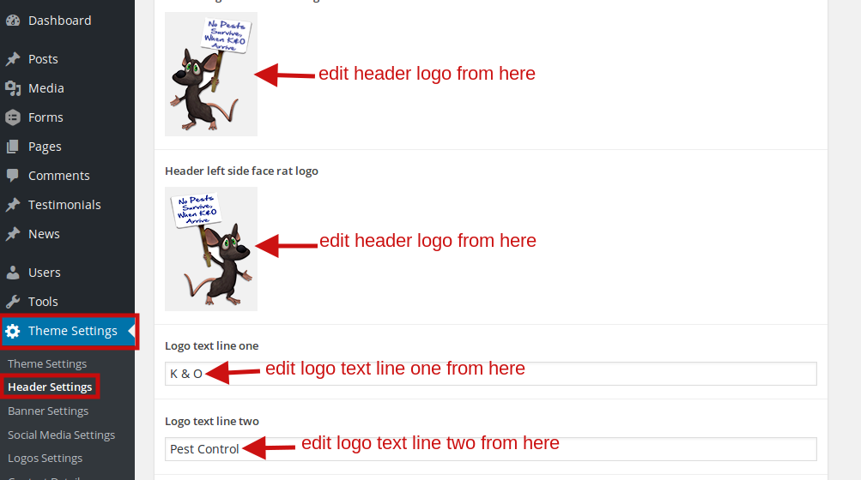

**(ii) How to manage header and footer contact details section:-**

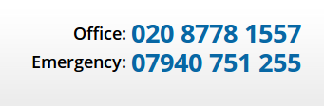

**Go to admin panel Dashboard -> Theme Settings -> Contact Details settings, we can change or edit according to screenshot :-**

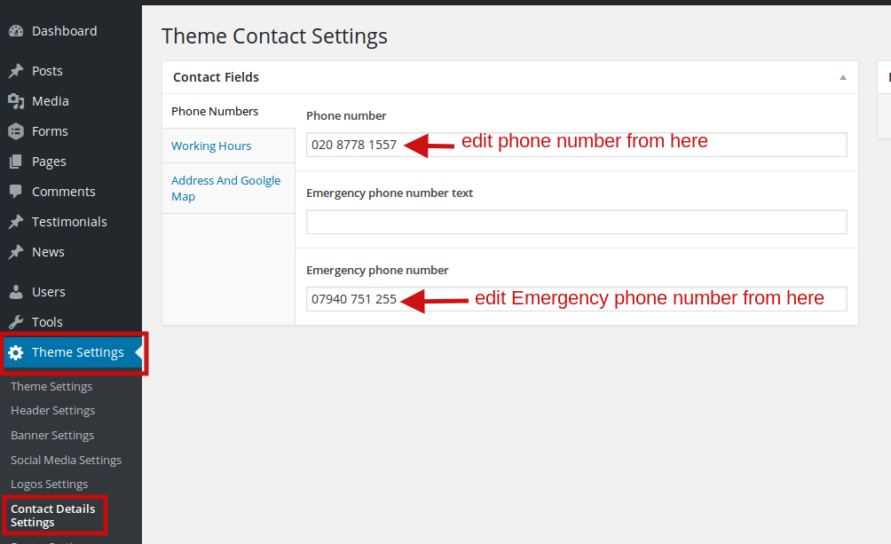

**(iii) How to manage this section :-**



**Go to admin panel Dashboard -> Theme Settings -> Header Settings, we can change or edit according to screenshot :-**

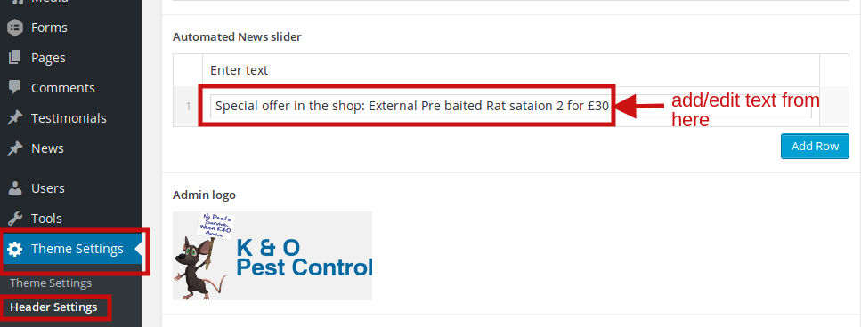

**2. How to manage home page slider section :-**

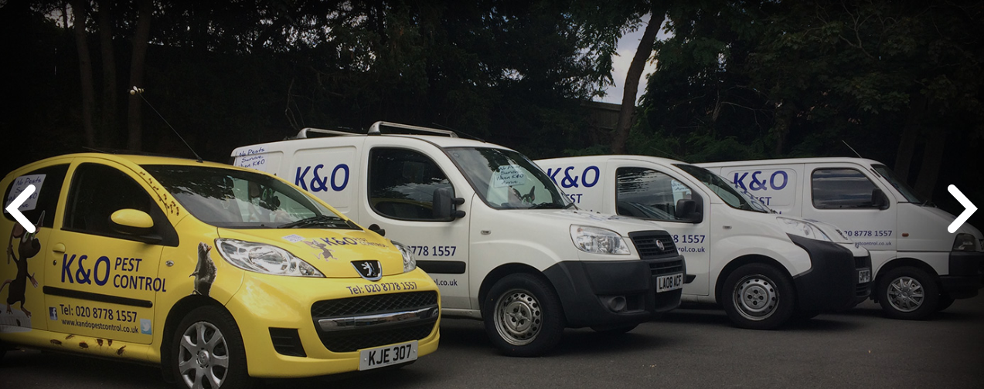

**Go to admin panel Dashboard -> Theme Settings -> Banner Settings, we can change or edit according to screenshot :-**

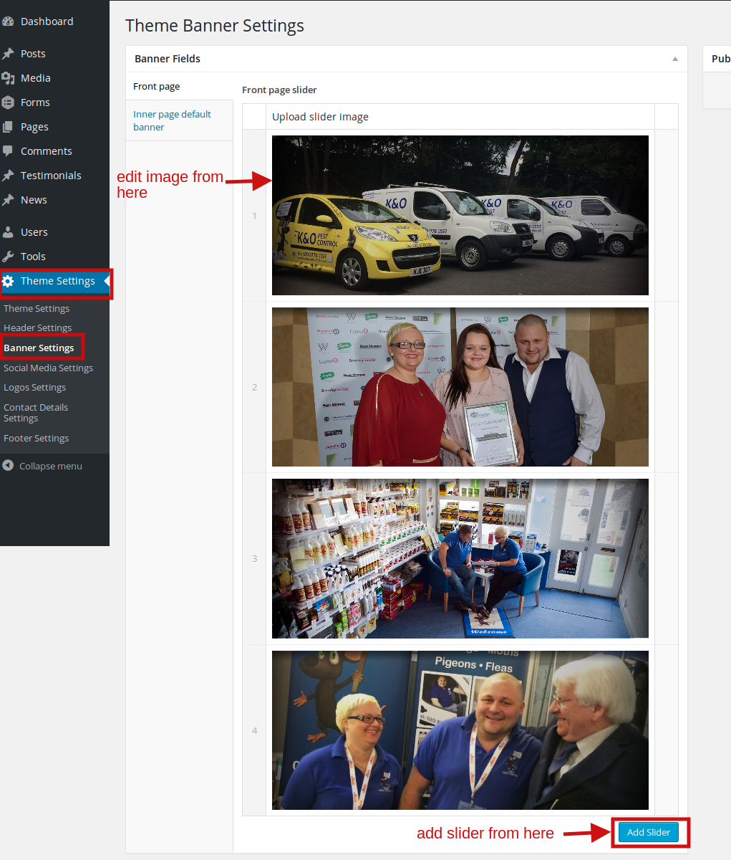

**3. How to manage Home Page :-**

**(i) How to manage video section :-**

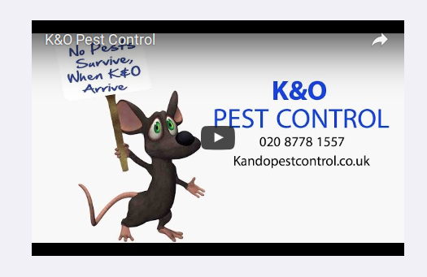

**Go to admin panel Dashboard -> Pages -> At A Glance, we can change or edit according to screenshot :-**

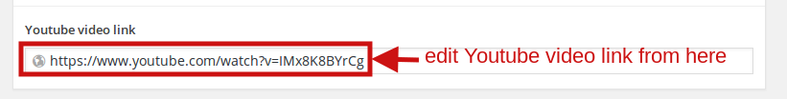

**(ii) How to manage this section :-**

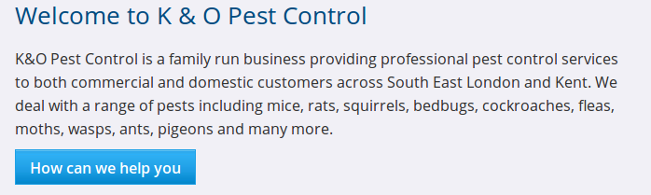

**Go to admin panel Dashboard -> Pages -> At A Glance, we can change or edit according to screenshot :-**

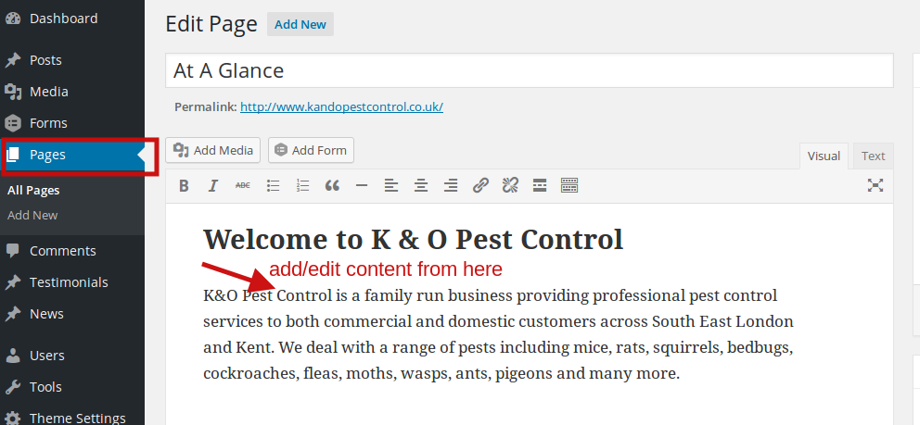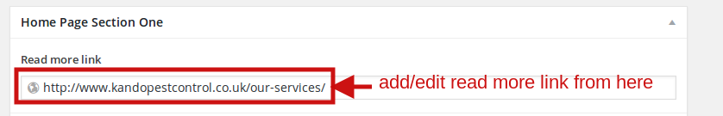

**(iii) How to manage social links section :-**



**Go to admin panel Dashboard -> Theme Settings -> Social Media Settings, we can change or edit according to screenshot :-**

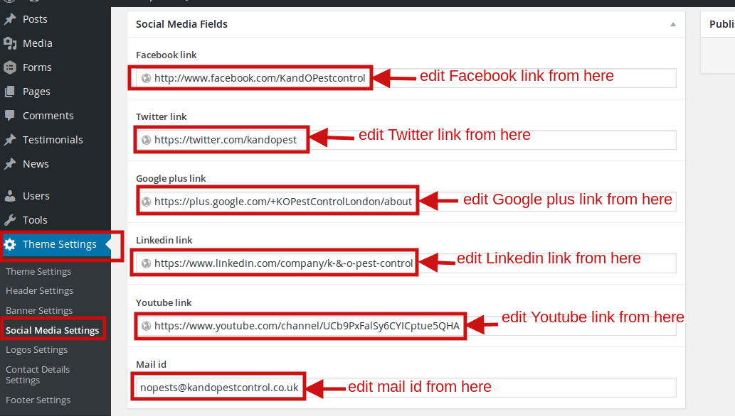

**(iv) How to manage this section :-**

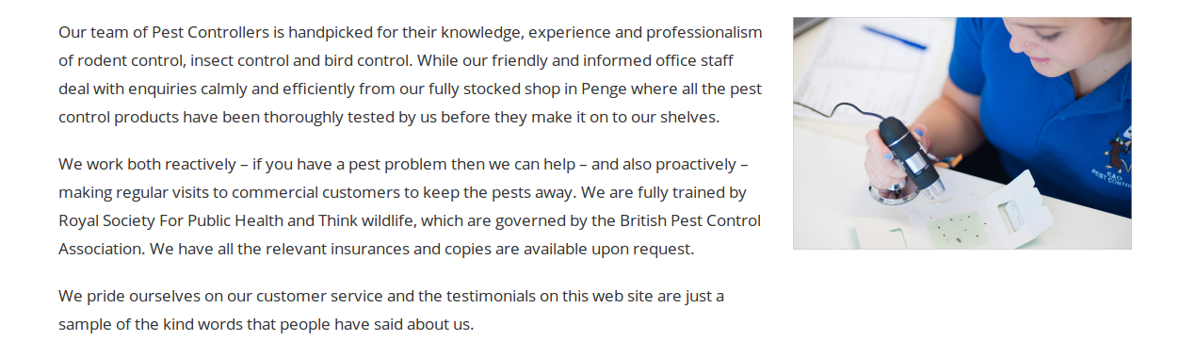

**Go to admin panel Dashboard -> Pages -> At A Glance, we can change or edit according to screenshot :-**

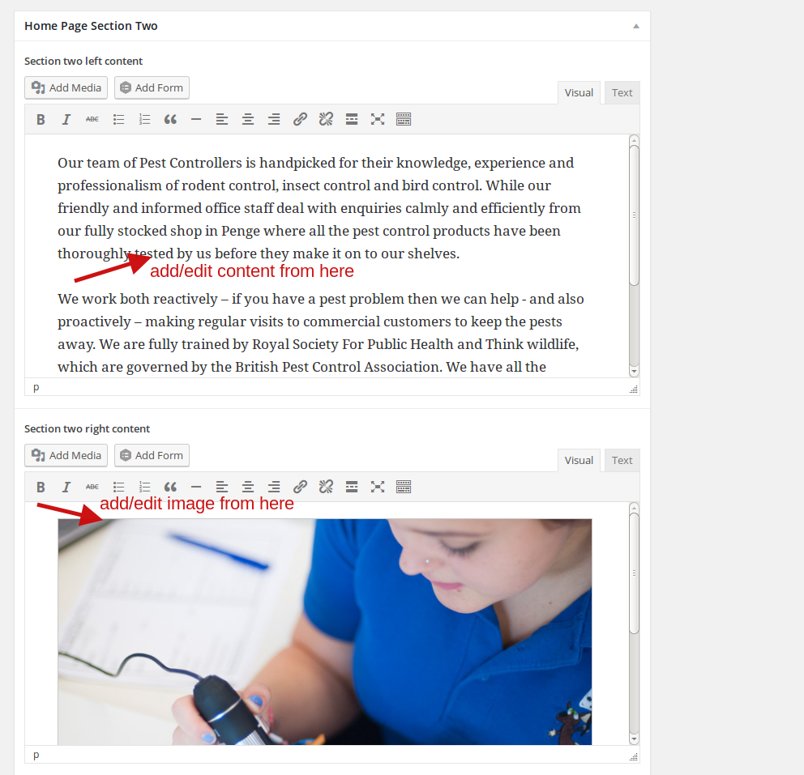

**(v) How to manage this section :-**

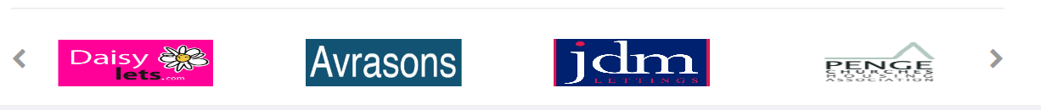

**Go to admin panel Dashboard -> Theme Settings -> Logos Settings, we can change or edit according to screenshot :-**

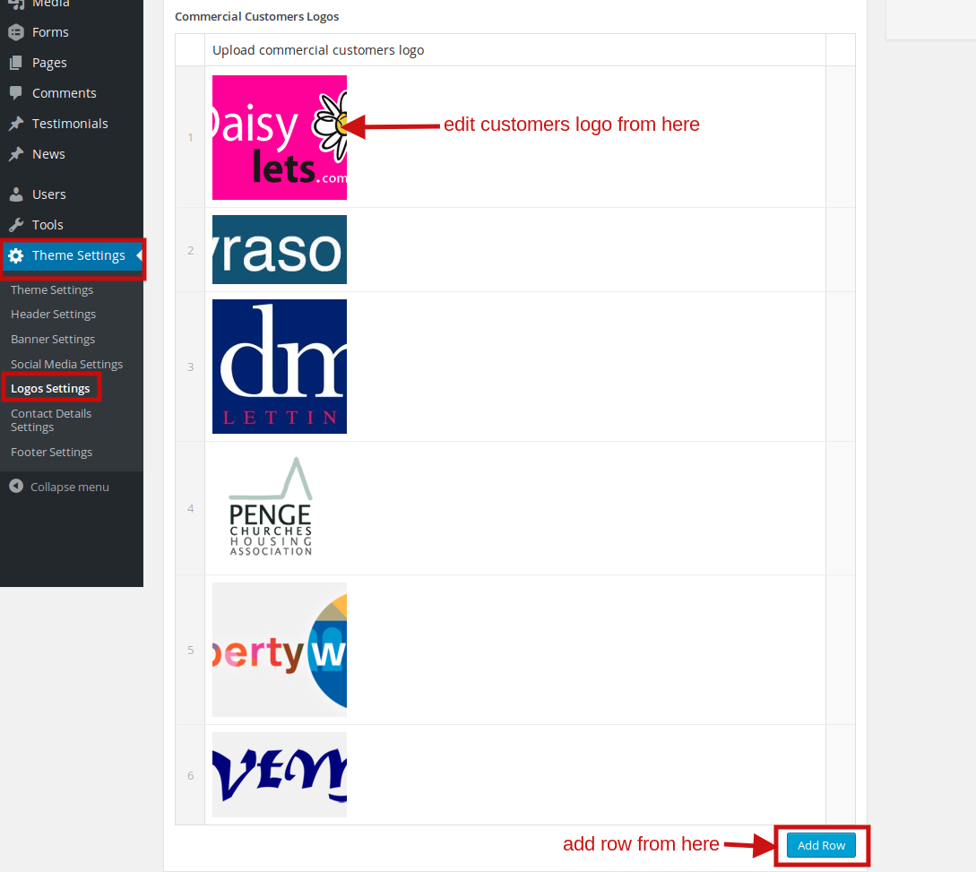

**4. Footer Setting :-**

**(i) How to manage this section :-**

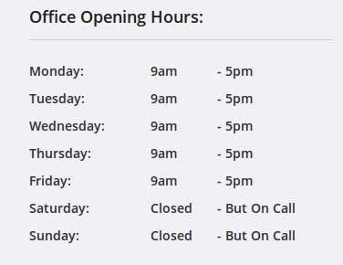

**Go to admin panel Dashboard -> Appearance -> Widgets -> Footer widget area , we can change or edit according to screenshot :-**

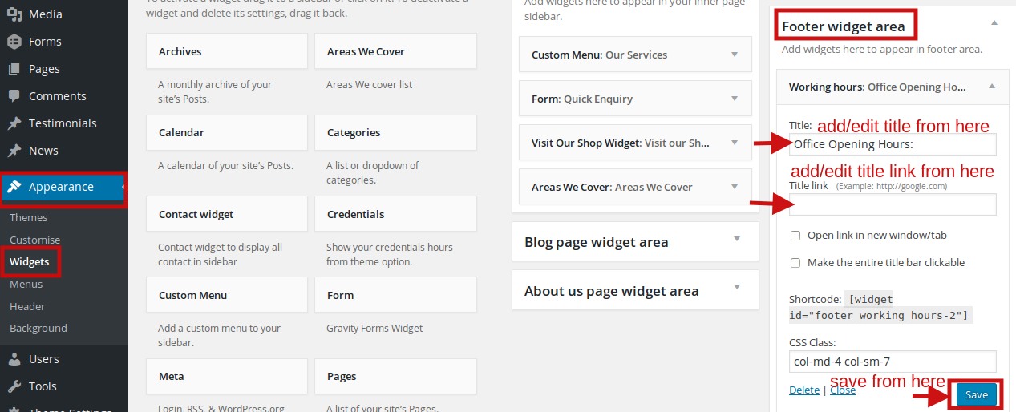

**(ii) How to manage this section :-**

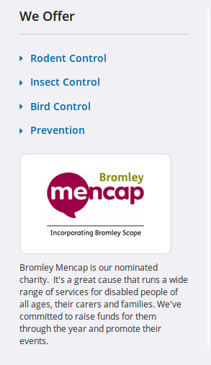

**Go to admin panel Dashboard -> Appearance -> Widgets -> Footer widget area, we can change or edit according to screenshot :-**

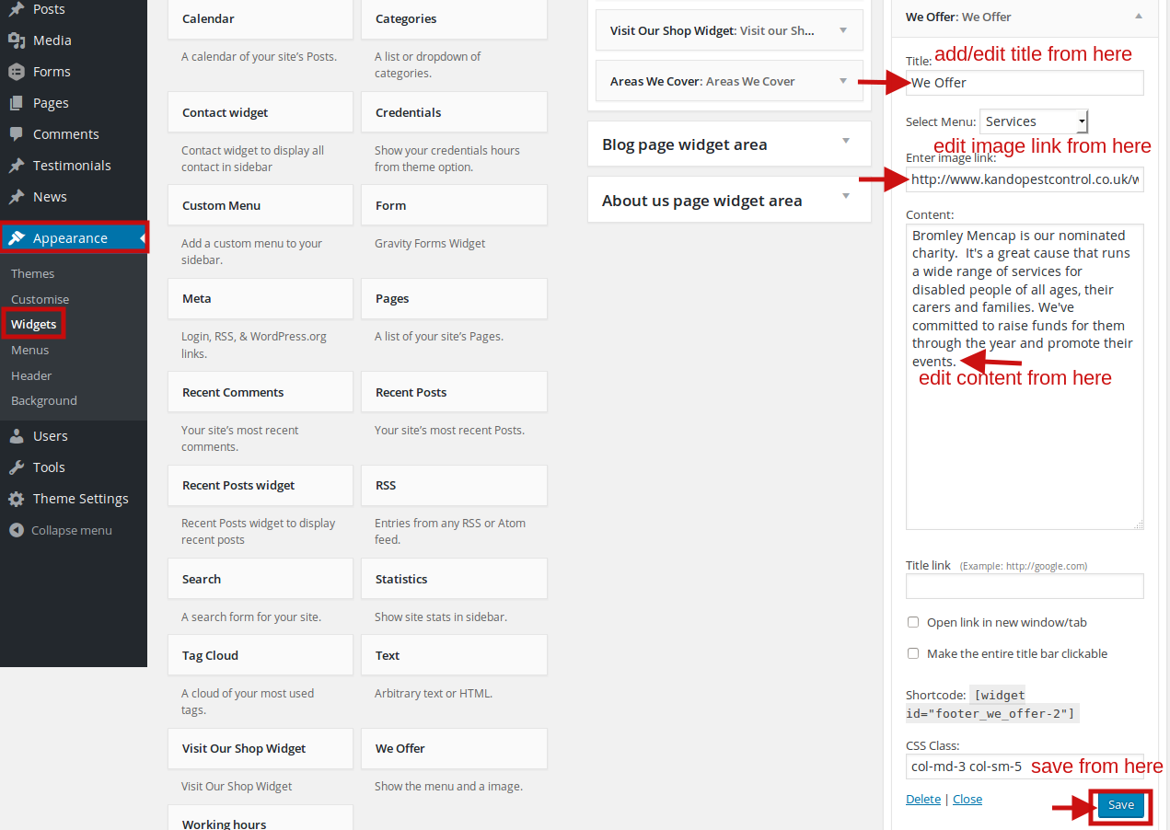

**(iii) How to manage this section :-**

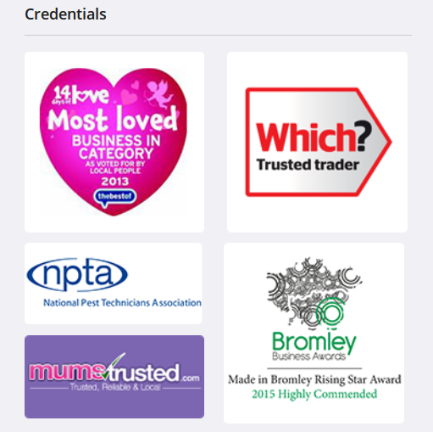

**Go to admin panel Dashboard -> Appearance -> Widgets -> Footer widget area, we can change or edit according to screenshot :-**

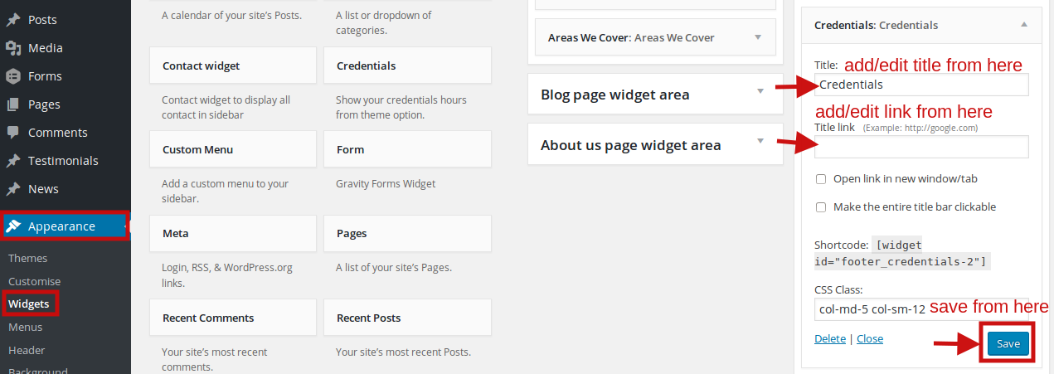

**Go to admin panel Dashboard -> Theme Setting -> Logos settings, we can change or edit according to screenshot :-**

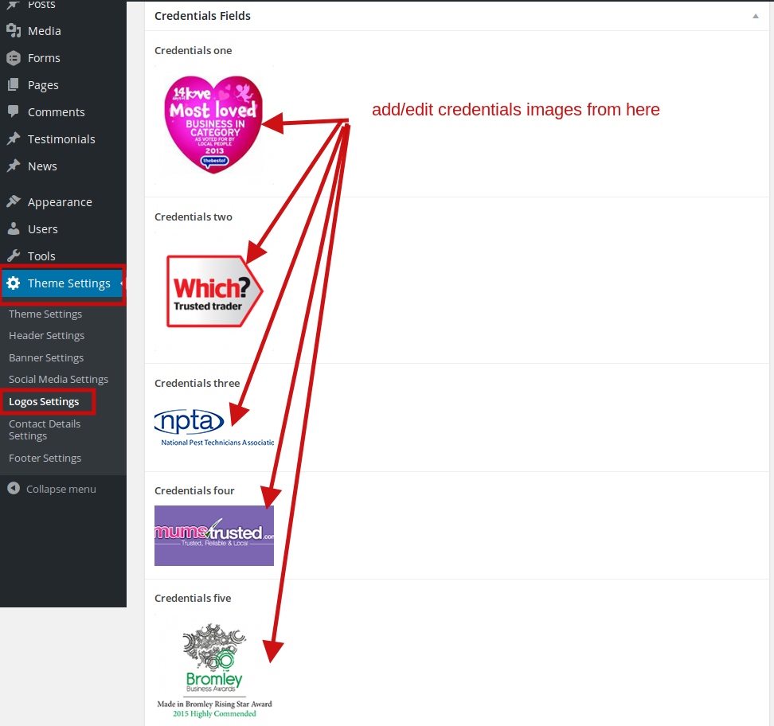

**(iv) How to manage this section :-**

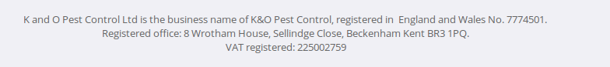

**Go to admin panel Dashboard -> Theme Settings -> Footer Settings, we can change or edit according to screenshot:-**

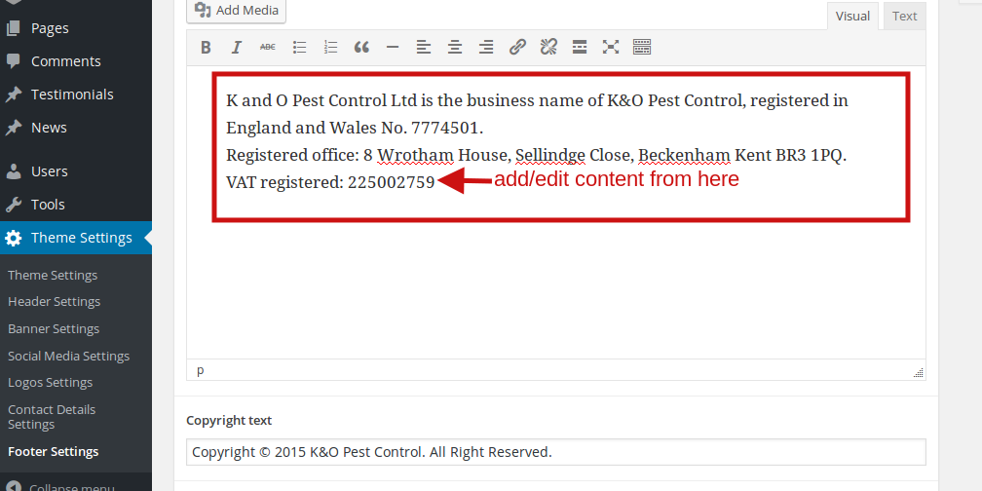

**(iii) How to manage this section :-**



**Go to admin panel Dashboard -> Theme Settings -> Footer Settings, we can change or edit according to screenshot :-**

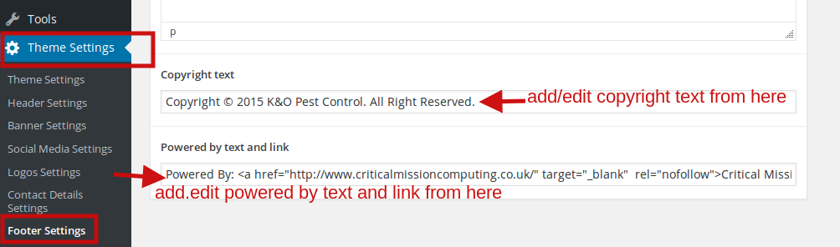

**5. How to manage About Us Page :-**

**(i) how to manage this section :-**

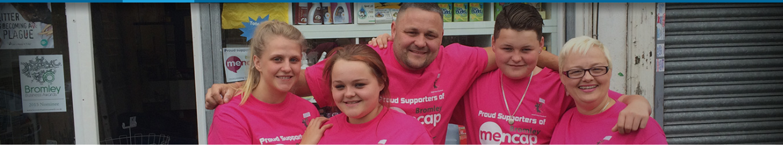

**Go to admin panel Dashboard -> Theme Settings -> Banner Settings, we can change or edit according to screenshot :-**

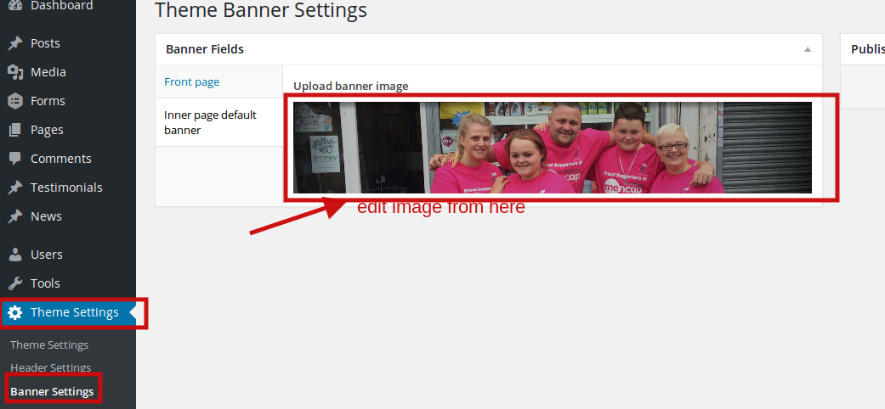

**(ii) how to manage this section :-**

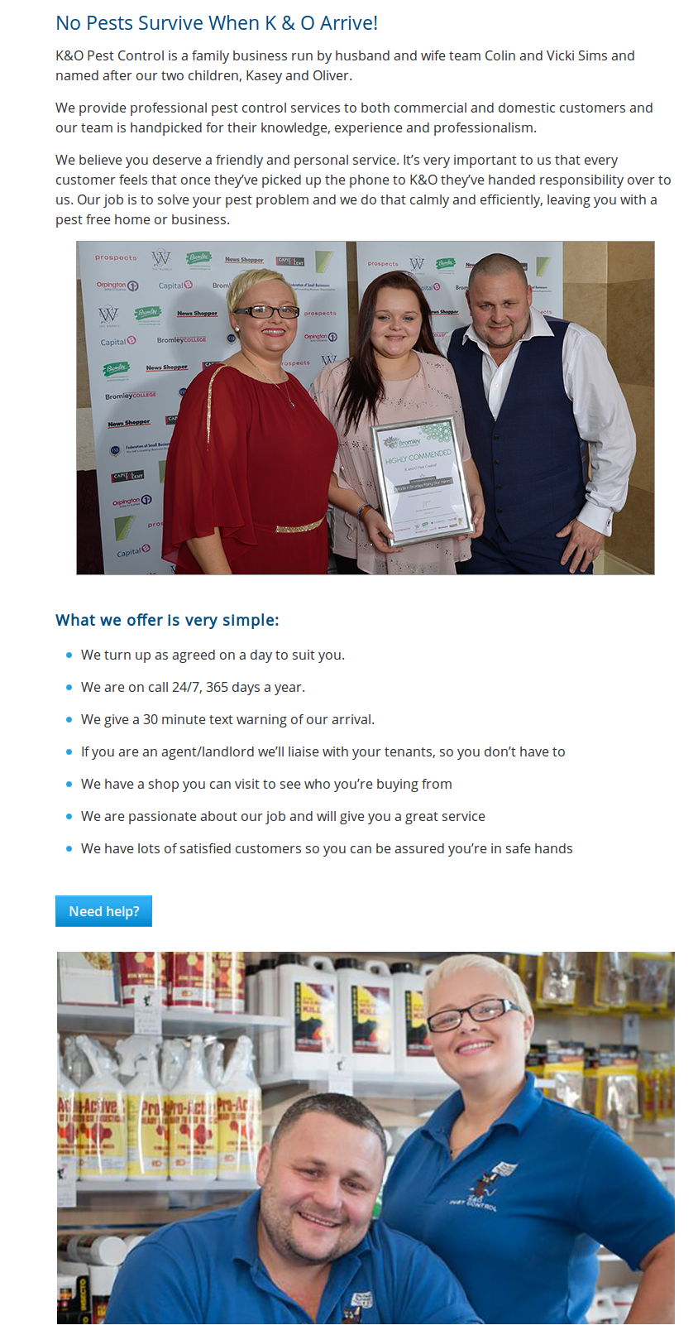

**Go to admin panel Dashboard -> Pages -> About Us, we can change or edit according to screenshot :-**

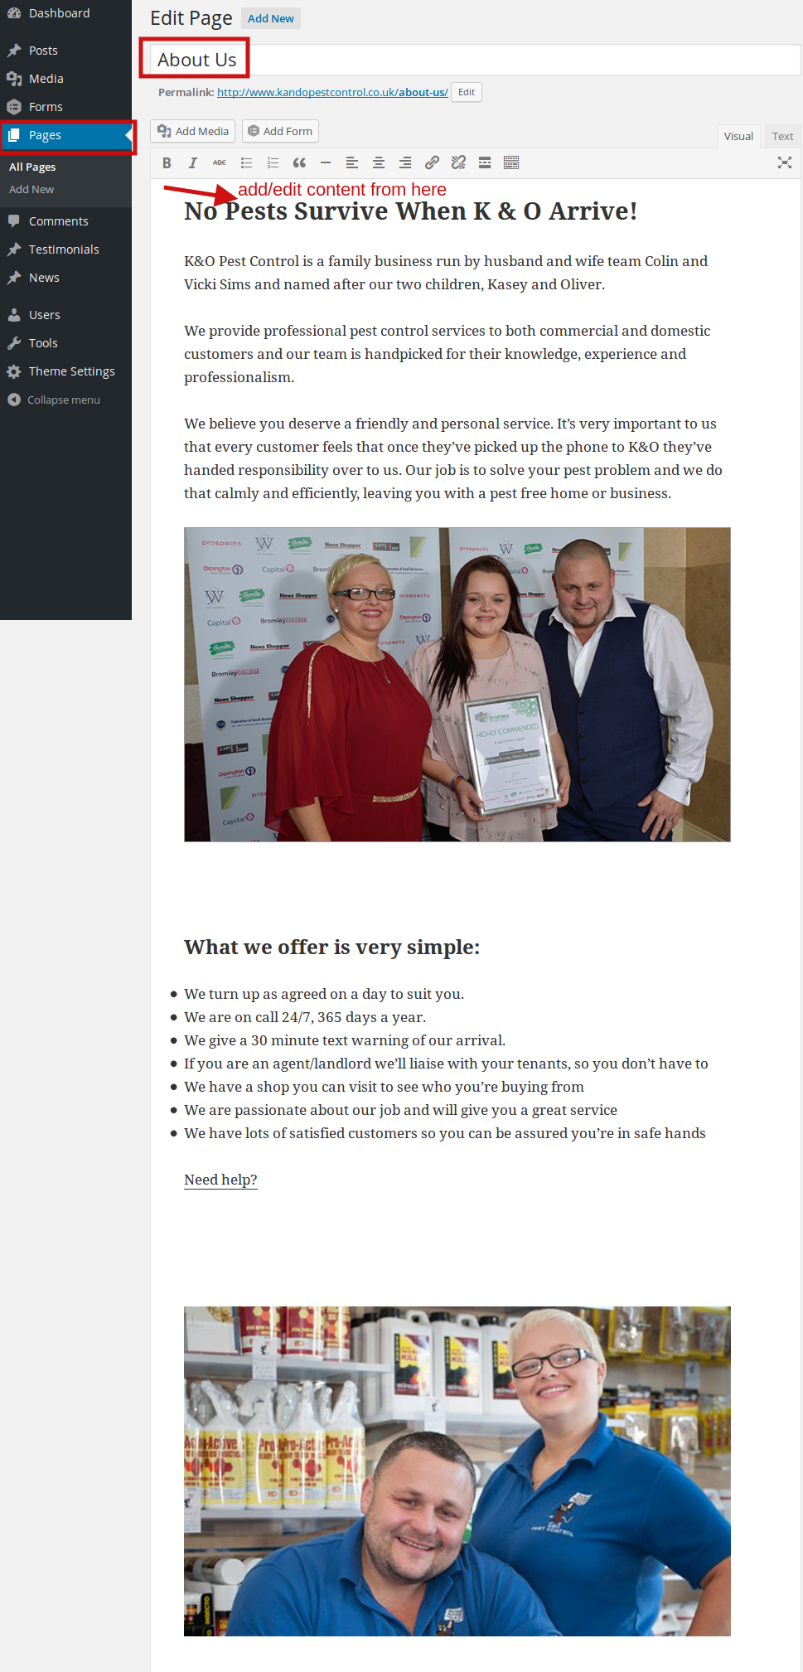

**6. How to manage Our Team page :-**

**(i) How to manage slider on our team page :-**

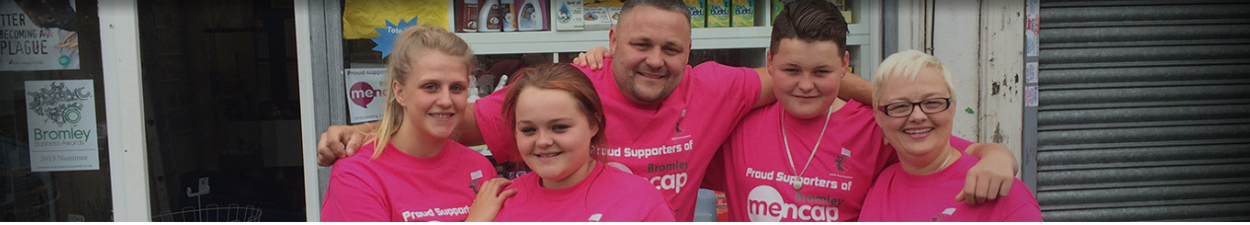

**Go to admin panel Dashboard -> Pages -> Our Team, we can change or edit according to screenshot :-**

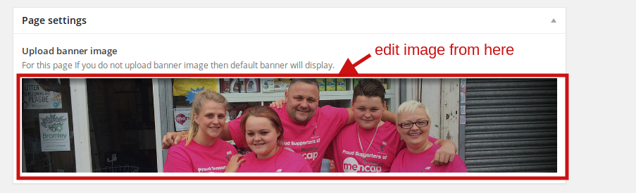

**(ii) How to manage this section :-**

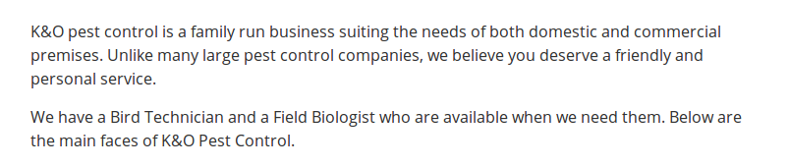

**Go to admin panel Dashboard -> Pages -> Our Team, we can change or edit according to screenshot :-**

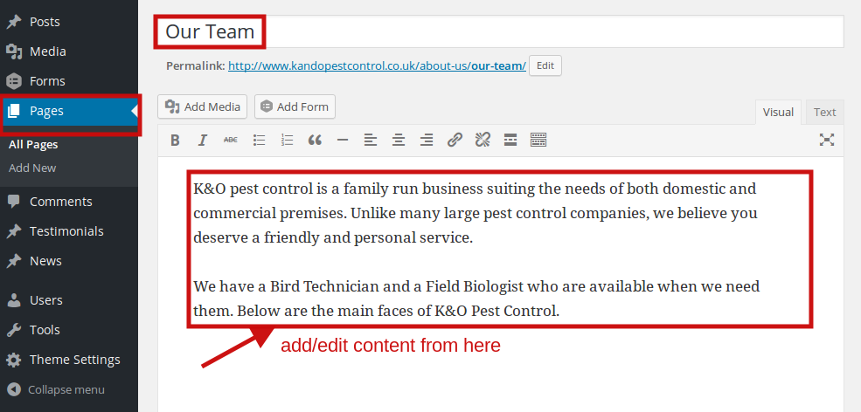

**(iii) How to manage this section :-**

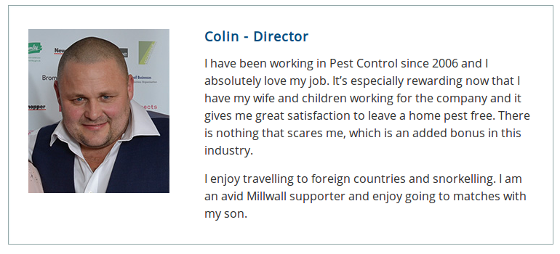

**Go to admin panel Dashboard -> Pages -> Our Team, we can change or edit according to screenshot :-**

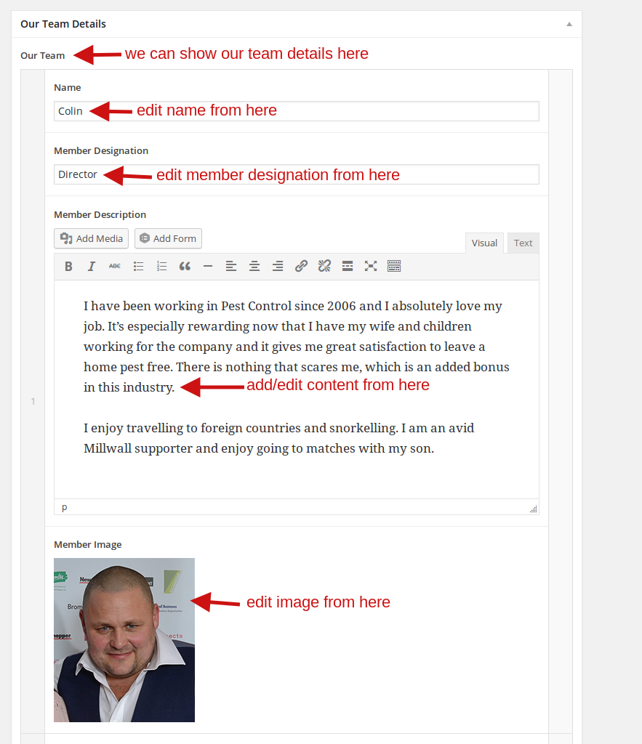

**7. How to manage Domestic Customers page :-**

**(i) how to manage this section :-**

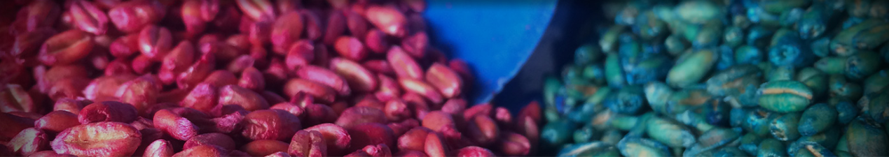

**Go to admin panel Dashboard -> Pages -> Domestic Customers, we can change or edit according to screenshot :-**

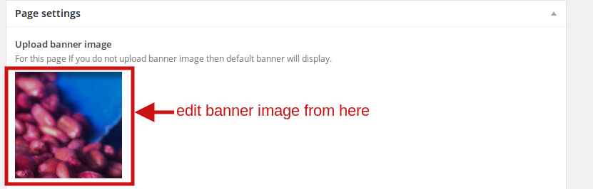

**(ii) How to manage this section :-**

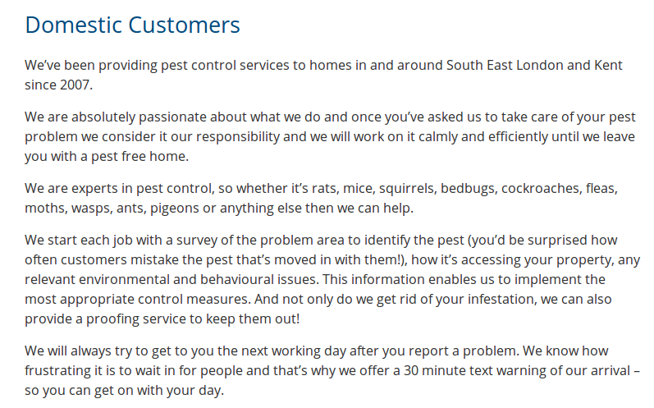

**Go to admin panel Dashboard -> Pages -> Domestic Customers, we can change or edit according to screenshot :-**

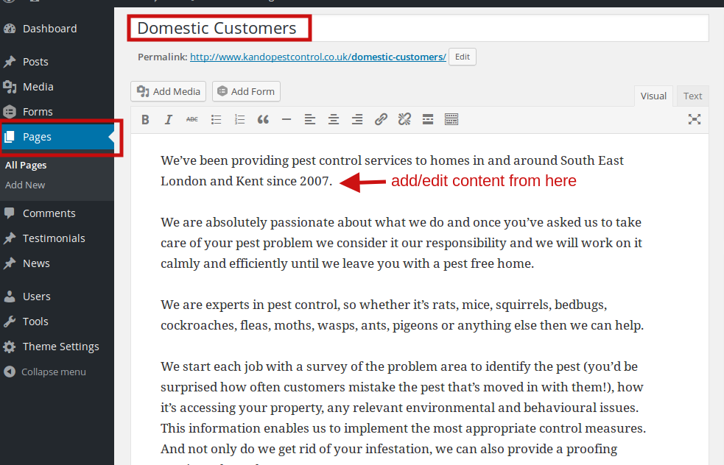

**(iii) How to manage this section :-**

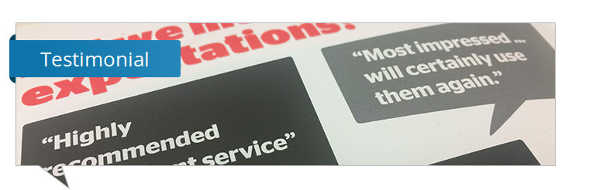

**Go to admin panel Dashboard -> Pages -> Domestic Customers, we can change or edit according to screenshot :-**

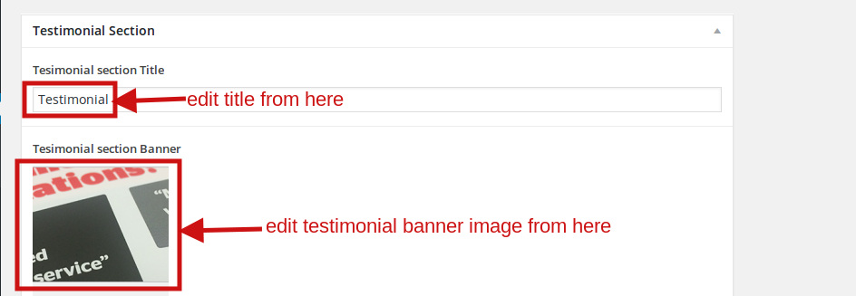

**(iv) How to manage this section :-**

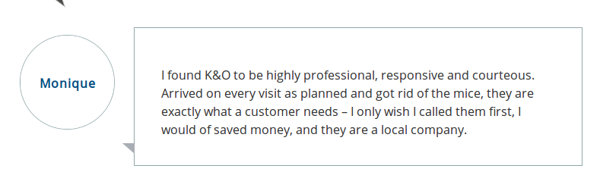

**Go to admin panel Dashboard -> Testimonials, we can change or edit according to screenshot :-**

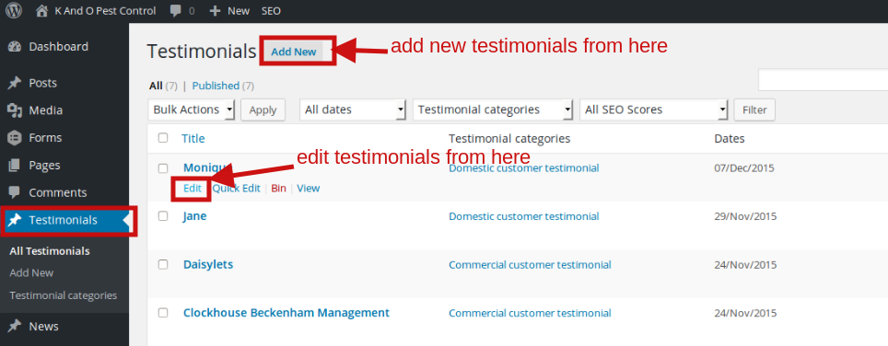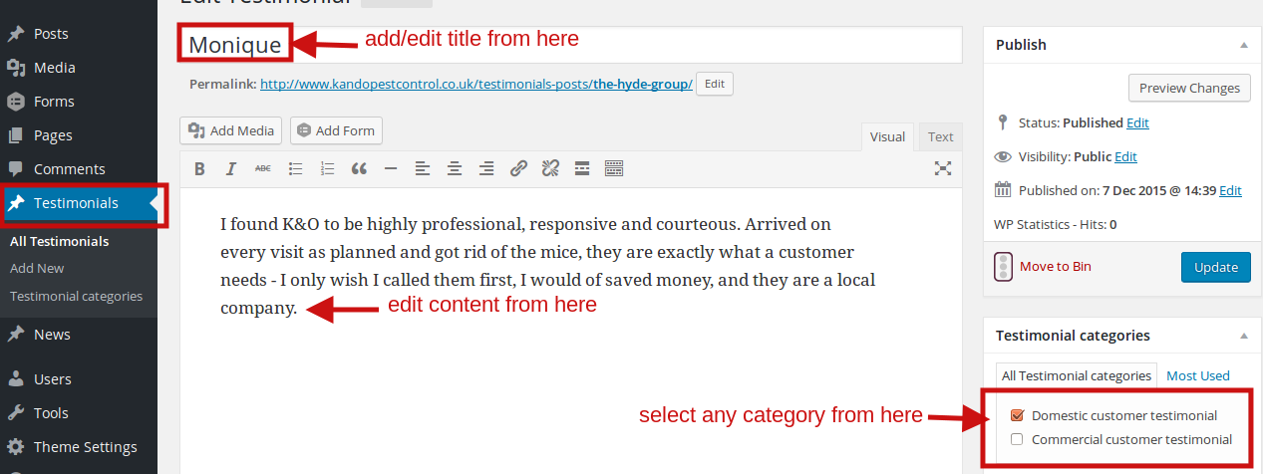

**(v) How to manage this section :-**



**Go to admin panel Dashboard -> Pages -> Domestic Customers, we can change or edit according to screenshot :-**

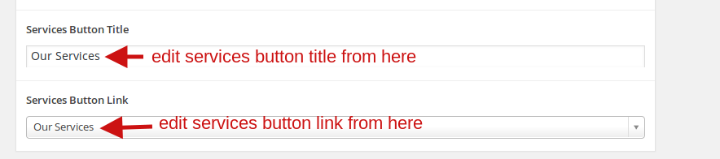

**8. How to manage Commercial Customers Page :-**

**NOTE :- as well as manage according to domestic customers page.**

**9. How to manage Our Services page :-**

**NOTE :- as well as manage according to domestic customers page banner .**

**(ii) How to manage this section :-**

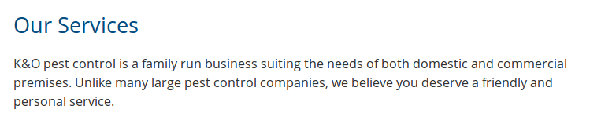

**Go to admin panel Dashboard -> Pages -> Our Services, we can change or edit according to screenshot :-**

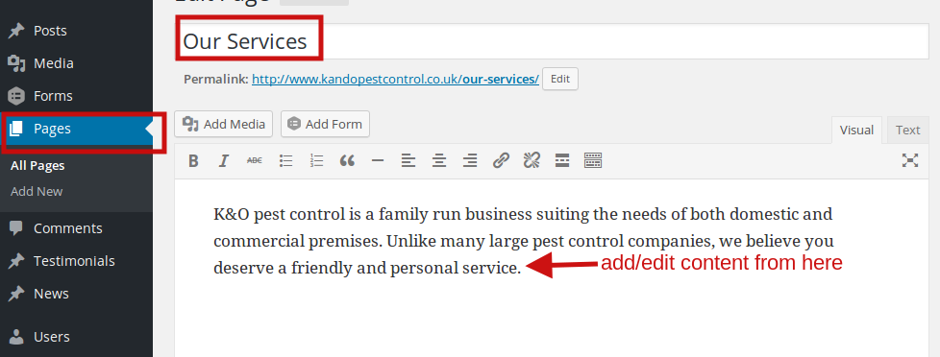

**10. How to manage shop page :-**

**(i) How to manage this section :-**

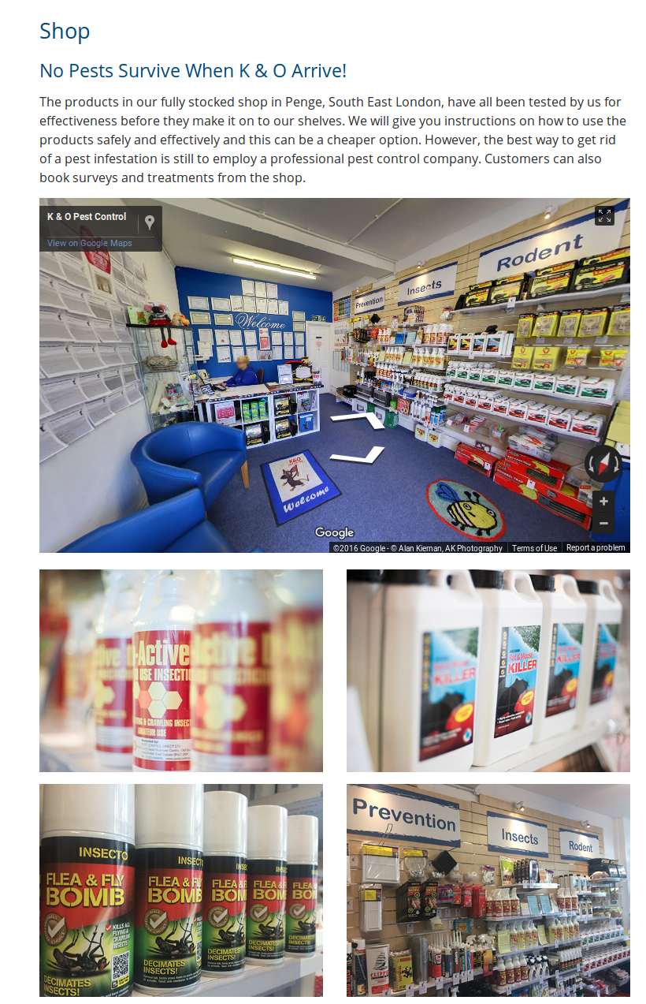

**Go to admin panel Dashboard -> Pages -> Shop, we can change or edit according to screenshot :-**

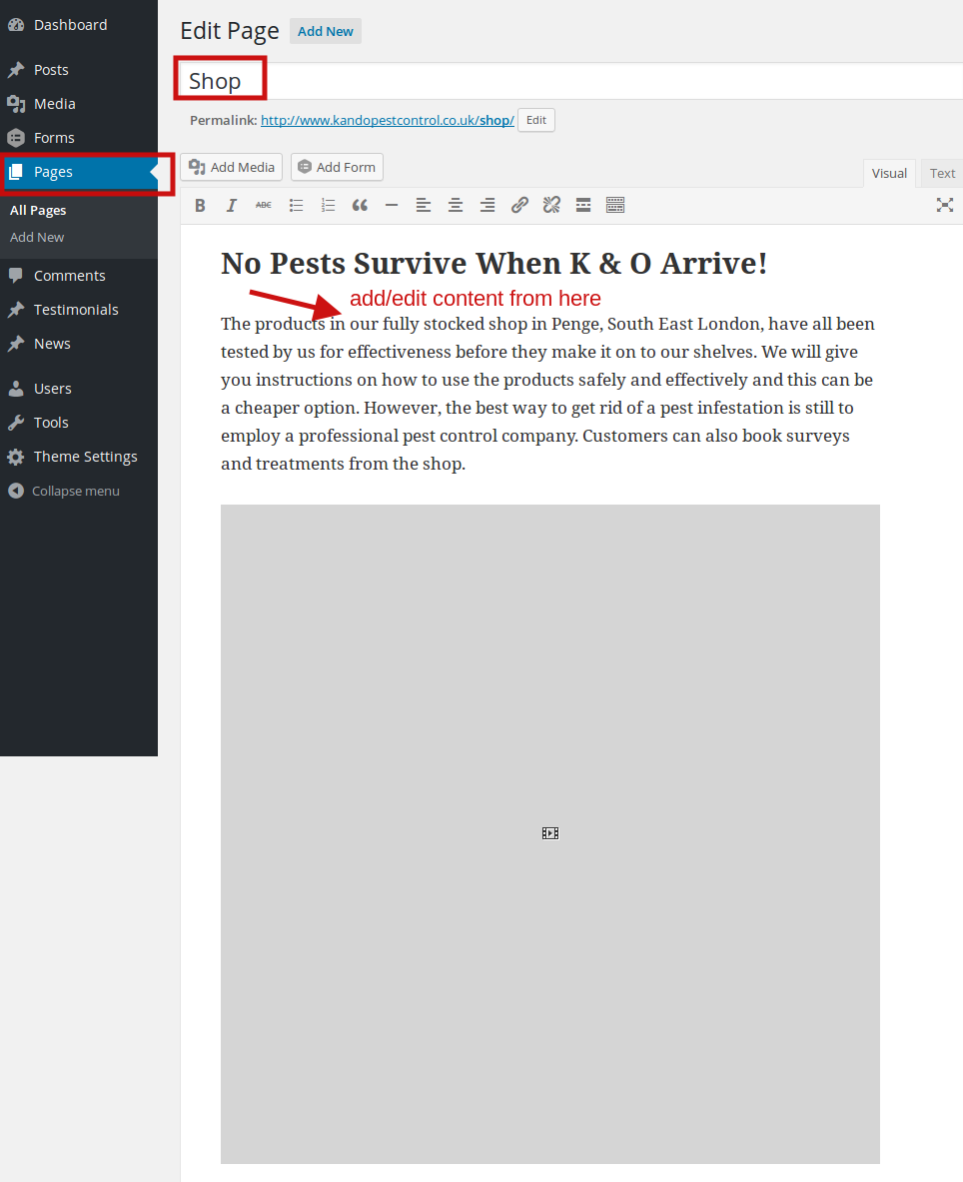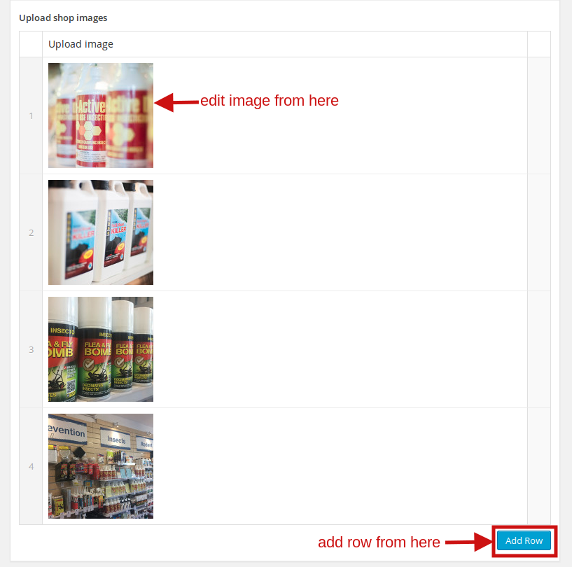

**11. How to manage News page :-**

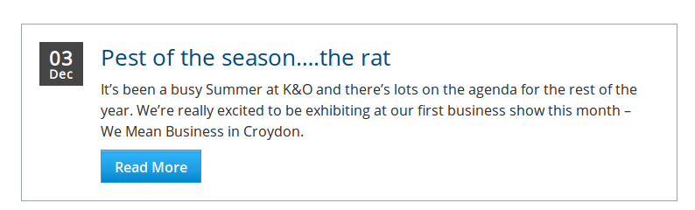

**Go to admin panel Dashboard -> News, we can change or edit according to screenshot :-**

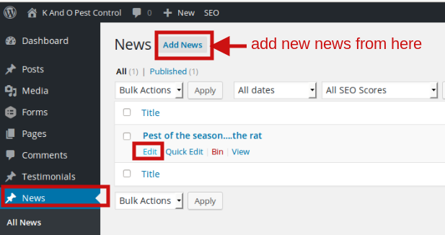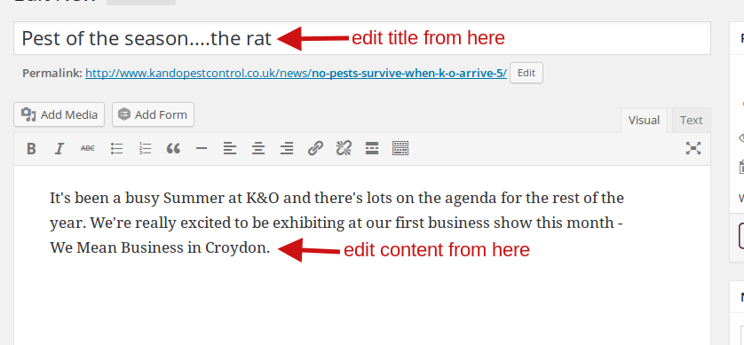

**When we click Read More link so open the pdf.**

**Go to admin panel Dashboard -> News, we can change or edit according to screenshot :-**

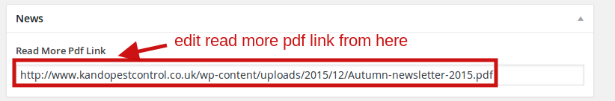

**12. How to manage Get in touch page :-**

**(i) How to manage this section :-**

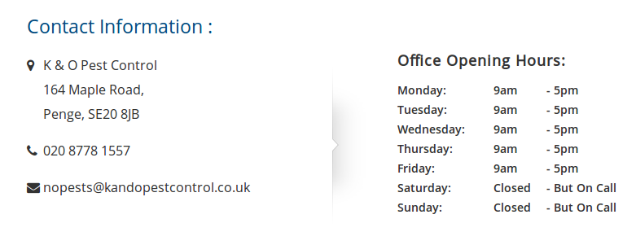

**Go to admin panel Dashboard -> Theme Settings -> Contact Details settings, we can change or edit according to screenshot:-**

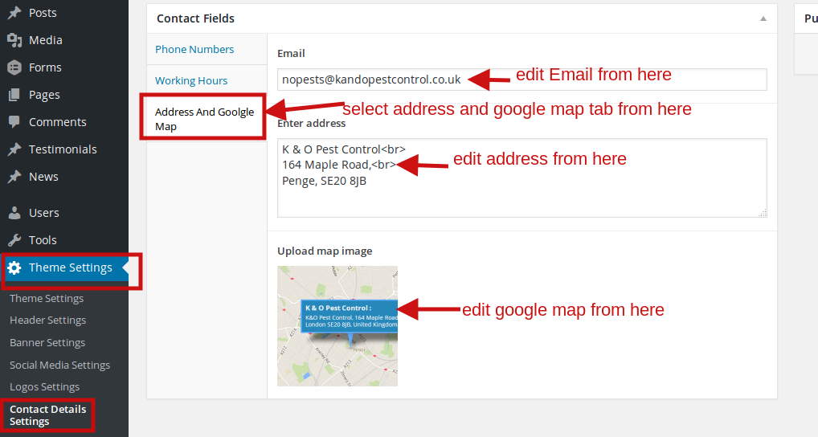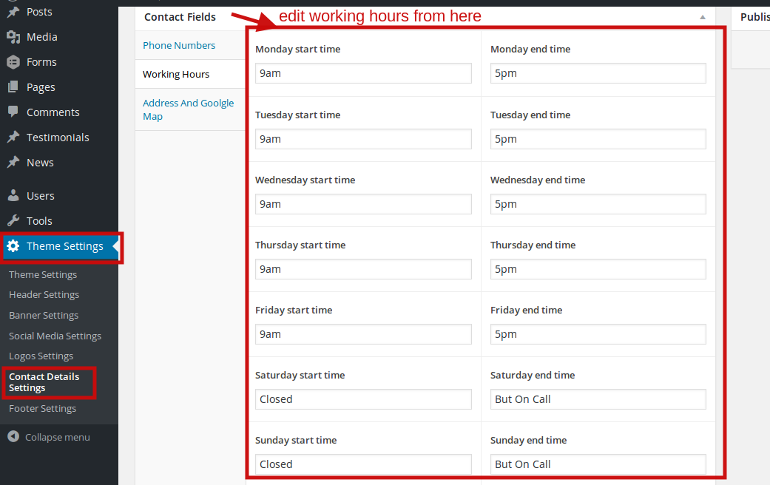

**13. How to see Contact Form leads:-**

**Go to admin panel Dashboard -> Forms , we can change or edit according to screenshot :-**

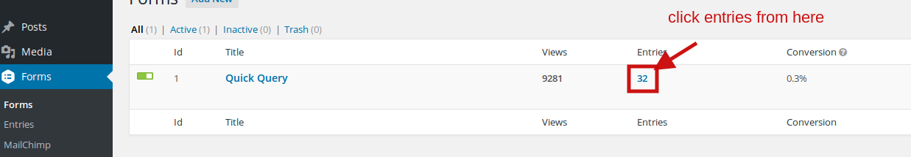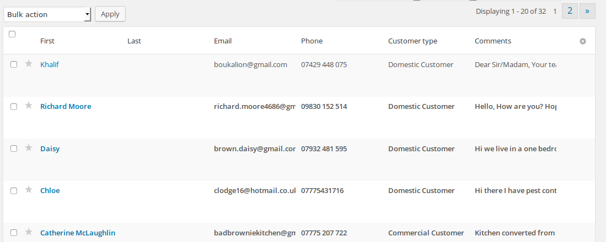

**14. How to manage About Us page sidebar section:-**

**(i) How to manage this section :-**

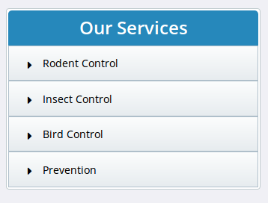

**Go to admin panel Dashboard -> Appearance -> Widgets -> About us page widget area, we can change or edit according to screenshot :-**

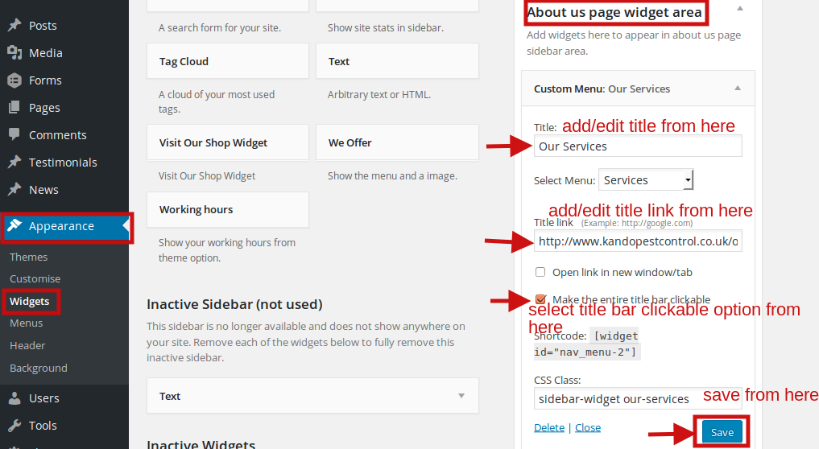

**(ii) How to manage this section :-**

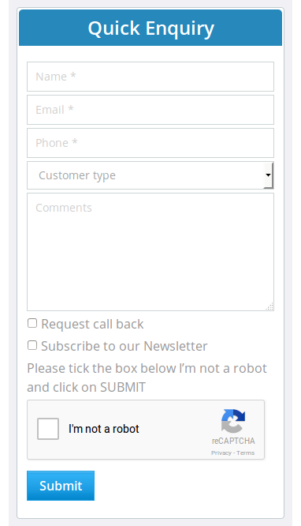

**Go to admin panel Dashboard -> Appearance -> Widgets -> About us page widget area, we can change or edit according to screenshot :-**

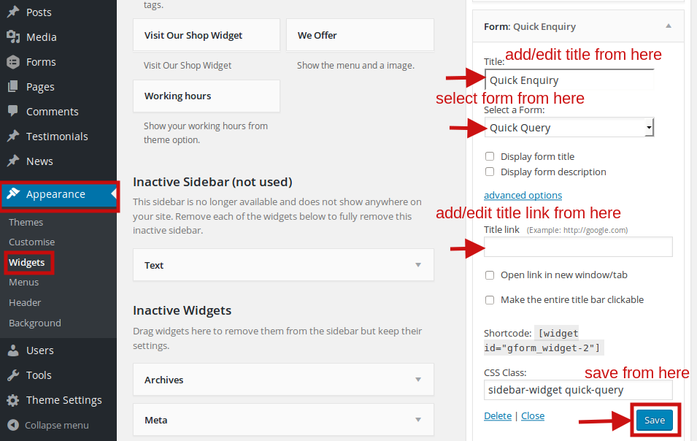

**(iii) How to manage this section :-**

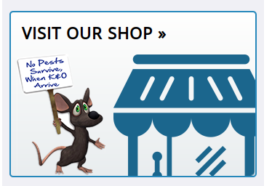

**Go to admin panel Dashboard -> Appearance -> Widgets -> About us page widget area, we can change or edit according to screenshot :-**

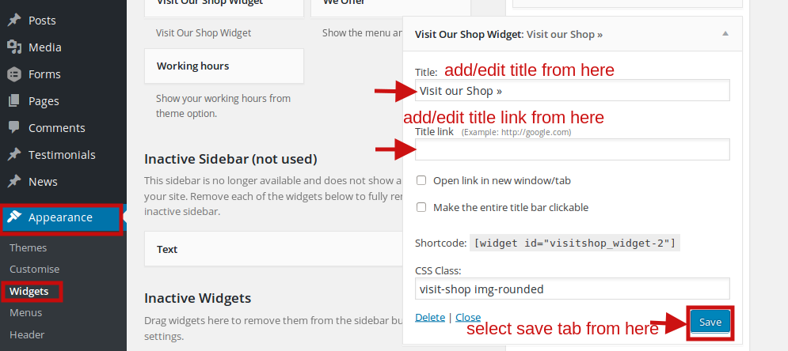

**(iv) how to manage this section:-**

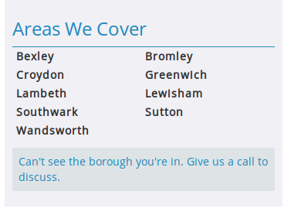

**Go to admin panel Dashboard -> Appearance -> Widgets -> About us page widget area, we can change or edit according to screenshot :-**

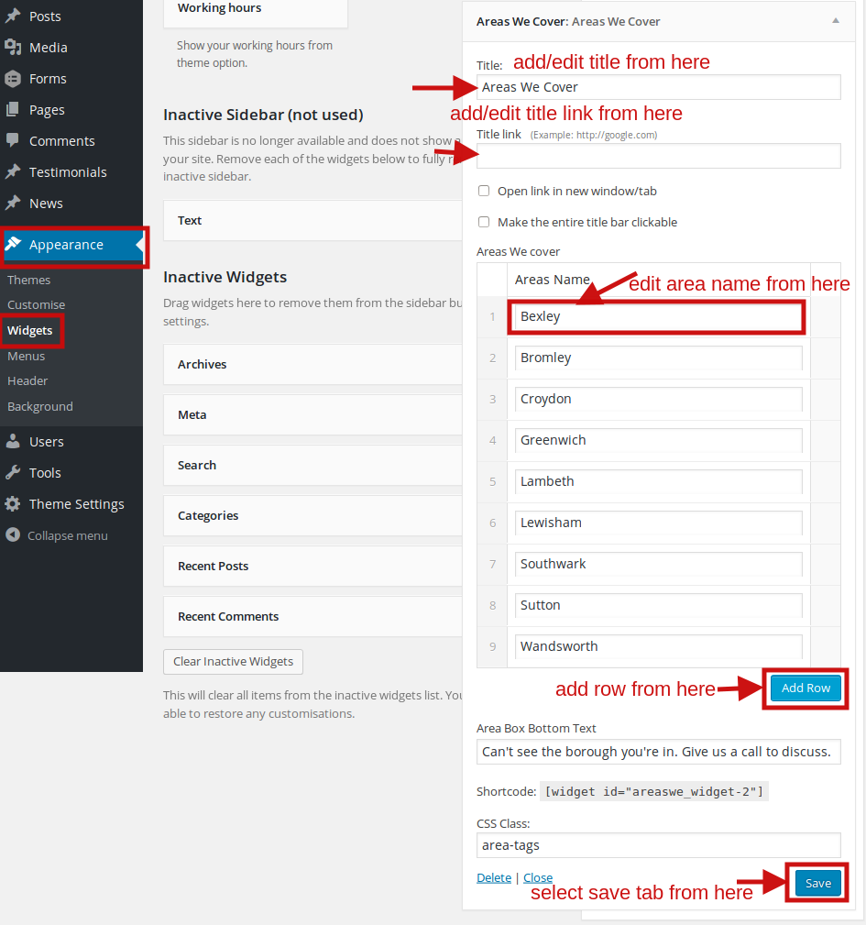

**15. How to manage widgets section :-**

**Go to admin panel Dashboard -> Appearance -> Widgets, we can change or edit according to screenshot :-**

